**P.1 GRAMMAR LESSON NOTES FOR TERM I**

|  |  |  |  |  |
| --- | --- | --- | --- | --- |
| Date | Class | L. Area | Duration | No. of pupils |
|  |  |  |  |  |

**THEME : Our school**

**SUBTHEME :People in our school.**

**CONTENT : Alphabetical letters**

**Small letters**

a b c d e f

g h I j k i

m n o p q r

s t u v w x

y z

**Capital letters**

A B D E F G H

I J K L M N O

P Q R S T U V

W X Y Z

**Example**

Change these words in small letters

BOOK – book

CHAIR – chair

**Exercise**

1. Write these letters in capital form.

a ___ f___ k ___ t __ m __

1. Write these words in capital letters.

girl ______ book _____ teacher _____ Esther ____

zebra ______

|  |  |  |  |  |
| --- | --- | --- | --- | --- |
| Date | Class | L. Area | Duration | No. of pupils |
|  |  |  |  |  |

**THEME : Our school**

**SUBTHEME :People in our school.**

**CONTENT : Re – arranging letters in alphabetical order**

a b c d e f g h I j k i m n o p q r s t u v w x y z

**words**

cat axe dog bag

axe bag cat dog

kid hat feet egg

egg feet hat kit

**Examples**

1. f c b a h

a b c f h

1. z w c k s

c k s w z

**Exercise**

**Re – arrange the following letters in alphabetical order**

1. d a b e c
2. i h e g f
3. i m j n k
4. book, door, chair, arrow
5. stick, tree, van, rat

|  |  |  |  |  |
| --- | --- | --- | --- | --- |
| Date | Class | L. Area | Duration | No. of pupils |
|  |  |  |  |  |

**THEME : Our school**

**SUBTHEME :People in our school.**

**CONTENT :Number names**

1. one
2. two
3. Three
4. Four
5. Five
6. Six
7. Seven
8. Eight
9. Nine
10. Ten
11. Eleven
12. Twelve
13. Thirteen
14. Fourteen
15. Fifteen
16. Sixteen
17. Seventeen
18. Eighteen
19. Nineteen
20. twenty

**Exercise**

1. **write these numbers in words**

**2 _________**

**5 __________**

**9___________**

**6___________**

**7___________**

**20___________**

**14____________**

**11____________**

**13___________**

**17____________**



1. How many ……………. are there?

** __________________**



|  |  |  |  |  |
| --- | --- | --- | --- | --- |
| Date | Class | L. Area | Duration | No. of pupils |
|  |  |  |  |  |

**THEME : Our school**

**SUBTHEME : People in our school.**

**CONTENT : Nouns**

A noun is a naming word.

For example: book , chair, pencil, Unaisha, Eran , peter

**Examples**

**Underline the nouns in the sentences**

1. This **tree** is big.
2. I am a clean **girl**.

**Exercise**

**Underline the nouns in the sentences**

1. That girl is good.
2. I have a big bag.
3. Mary is clever
4. John has a table.
5. The chair is small.

|  |  |  |  |  |
| --- | --- | --- | --- | --- |
| Date | Class | L. Area | Duration | No. of pupils |
|  |  |  |  |  |

**THEME :** Our school

**SUBTHEME :** People in our school.

**CONTENT : Articles**

**Articles “a”**

Article “a” is used before a noun beginning with a consonant sound.

**Examples**

b, c, d, f, g, h, j, k, l, m, n, p, q, r, s, t, v, w, x, y , z

**a** book

**a** cat

**a** cupboard

**Sentences**

* This is a book.
* I can see a cat.

**Exercise**

**Fill in with “a”**

1. Mummy has ___spoon.
2. I can see ____table.
3. Tom is carrying ____cup.
4. They are playing with ____ball.
5. Here is ___duster
6. *My father has bought _______ car*
7. *The teacher has _____ stick and ________ pen.*

|  |  |  |  |  |
| --- | --- | --- | --- | --- |
| Date | Class | L. Area | Duration | No. of pupils |
|  |  |  |  |  |

**THEME :** Our school

**SUBTHEME :** People in our school.

**CONTENT : Articles “an”**

**Articles “an”**

Article “an” is used before a noun starting with vowel sounds.

a e i o u

**Examples**

**an** apple **an** egg **an** inkpot **an** onion

**an** elephant **an** eagle **an** umbrella **an** orange

**an** old man

**Exercise**

**Fill in “a” or “an” correctly**

__cup __elephant __door __umbrella

__insect __table __basket __orange

__egg __mango __arrow __hour __tree

__inkpot

|  |  |  |  |  |
| --- | --- | --- | --- | --- |
| Date | Class | L. Area | Duration | No. of pupils |
|  |  |  |  |  |

**THEME : Our school**

**SUBTHEME : Things in our school.**

**CONTENT :**

- blackboard - duster - bucket - table - pieces of chalk

- bus - bench - stool - jerry can - chair

- bag - towel - window - stick - ball

- ruler - computer - pen - desk - book

- basket - pencil - pen - cupboard - charts

- school van - ruler - mattress - cup - rubber

- bed - plate - box

**Exercise**

1. **Fill in the missing letters.**

P__ncil d__sk ch__ir ch__rts

t__ble rul__r w__ndow

c__mputer st__ck st__ __l

br__ __m bru__h b__d

1. Draw these pictures

|  |  |  |
| --- | --- | --- |
|  |  |  |
| duster | pen | desk |
|  |  |
| stick | book |

**Name these pictures**

|  |  |  |  |
| --- | --- | --- | --- |
|  |  |  |  |
|  |  |  |  |
|  |  |  |  |
|  |  |  |  |

|  |  |  |  |  |
| --- | --- | --- | --- | --- |
| Date | Class | L. Area | Duration | No. of pupils |
|  |  |  |  |  |

**THEME : Our school**

**SUBTHEME : Things in our school.**

**CONTENT : plurals of things in our school**

**one many**

blackboard - blackboards

table - tables

bench - benches

chalkboard - chalkboard

chair - chairs

window - windows

ruler - rulers

desk - desks

pencil - pencils

chart - charts

mattress - mattresses

bed - beds

broom - brooms

brush - brushes

duster - dusters

bag - bags

computer - computers

book - books

|  |  |  |  |  |
| --- | --- | --- | --- | --- |
| Date | Class | L. Area | Duration | No. of pupils |
|  |  |  |  |  |

**THEME : Our school**

**SUBTHEME : Activities done at school.**

**CONTENT : plurals where we add “s”**

**Singular (one) plural (many)**

chair - chairs

girl - girls

basket - baskets

book - books

stool - stools

pencil - pencils

bag - bags

bird - birds

desk - desks

tree - trees

school - schools

blackboard - blackboards

ruler - rulers

bucket - buckets

stick - sticks

**Exercise**

**Complete correctly**

1. Those __________________are mine. (book)
2. I have many __________________(pencil)
3. These are nice __________________(bag)
4. ________________are found in classrooms.(blackboard)
5. We use___________________ for sweeping.(broom)
6. All __________________have feathers.(bird)
7. Those ________________________________are smart.(girl)
8. *One boy but two _________________*
9. *One desk but four ________________*
10. *One pencil but three ______________*

*2. Fill in correctly*

a) one bird two _______________

one flower three ______________

one broom four ______________

|  |  |  |  |  |
| --- | --- | --- | --- | --- |
| Date | Class | L. Area | Duration | No. of pupils |
|  |  |  |  |  |

**THEME : Our school**

**SUBTHEME : Activities done at school.**

**CONTENT : Plurals where with “es”**

We add es on words which end with

Ss, o, ch, sh, x, s to make their plurals.

|  |  |
| --- | --- |
| **One** | **Many** |
| box | boxes |
| church | churches |
| mango | mangoes |
| gas | gases |
| class | classes |
| tomato | tomatoes |
| dress | dresses |
| dish | dishes |
| brush | brushes |
| branch | branches |
| fox | foxes |
| watch | watches |
| bench | benches |
| bunch | bunches |

**Exercise**

**Write plurals of the given words**

tomato _________________ box ____________________

branch__________________ class___________________

glass___________________ watch__________________

church__________________ bench__________________

mango____________________

brush_____________________ fox _____________________

**EVALUATION :**

1. Most _________________are red in colour (tomato)
2. Trees have __________________(branch)
3. We have many ____________________at school (class)
4. She has nice ________________in her room (dress)
5. These ___________________are big. (box)
6. ___________________are sweet (mango)
7. Those ________________are expensive.(dish)
8. I have two ______________________. (watch)
9. Here are ten __________________________. (bench)
10. We use ______________________to brush our teeth.(brush)

|  |  |  |  |  |
| --- | --- | --- | --- | --- |
| Date | Class | L. Area | Duration | No. of pupils |
|  |  |  |  |  |

**THEME : Our school**

**SUBTHEME :**

**CONTENT : Opposites of nouns**

girl – boy

sister – brother

mother – father

uncle – aunt

woman – man

lady – gentleman

waiter – waitress

head girl – head boy

son – daughter

Mr. - Mrs.

Nephew - niece

Prince - princess

King - queen

Lord - lady

Policeman - _________________

Grand father - _________________

girls _________________

|  |  |  |  |  |
| --- | --- | --- | --- | --- |
| Date | Class | L. Area | Duration | No. of pupils |
|  |  |  |  |  |

**THEME : Our Home**

**SUBTHEME : People found at home**

**CONTENT : Prepositions.**

On , in , under , near, to, at

Where is the ____________________?



The ball is ______________the chair.



The flower is __________________the tin.



 The bird is flying __________ the tree



The book is ______________________the table.

The snake is __________________________the bench.

Water is _____________________the glass.



 Tom is standing _____________the tree.





Kapere is sitting ________________________the chair.



 Brenda is going __________ school



He is looking ________ the sun

A preposition is a word used to show where a noun is.

**Using pictures and learners make sentences**









|  |  |  |  |  |
| --- | --- | --- | --- | --- |
| Date | Class | L. Area | Duration | No. of pupils |
|  |  |  |  |  |

**THEME : Our Home**

**SUBTHEME : Activities done at home**

**CONTENT : More prepositions**

at , behind , to , in front of

1. Mukasa is pointing _____________the sun.

2. The tree is ____________the house.





3. They are sitting ________________the bench.



4. Namuddu is standing ___________the car.





5. He is looking __________the bird.

|  |  |  |  |  |
| --- | --- | --- | --- | --- |
| Date | Class | L. Area | Duration | No. of pupils |
|  |  |  |  |  |

**THEME : Our school**

**SUBTHEME : People found at home**

**CONTENT : Punctuations (Capital letters)**

These are used when beginning a statement / sentence or a question and months of the year.

**Punctuation** **marks**:- Are signs used to be put at the end of the sentence.

**Capital** **letters**: - These are used when beginning a statement

**Examples**

1. **T**he boy is under the tree.
2. **I** am going to **K**ampala.
3. **H**ow old are you?
4. **W**hat is your name?
5. **M**y name is Namukasa.

**Exercise**

**Punctuate the given statements.**

1. ben is a good boy
2. i am six years old
3. how old are you?
4. edrine is my brother
5. Our capital city is kampala

|  |  |  |  |  |
| --- | --- | --- | --- | --- |
| Date | Class | L. Area | Duration | No. of pupils |
|  |  |  |  |  |

**THEME : Our school**

**SUBTHEME : People found at school**

**CONTENT : Full stop (.)**

It is used to show that the sentence has ended / abbreviation.

**Examples**

My class teacher is Tr. Asiimwe.

My name is Namata.

That is a fat man.

**Exercise**

**Punctuate correctly**

1. The woman is riding a bicycle. ___________
2. I have five apples ______________
3. That is Mr. Kaggwa.___________
4. Dr. Matovu is a tall man. _______________
5. Our director is madam Faith Muyonga._________

|  |  |  |  |  |
| --- | --- | --- | --- | --- |
| Date | Class | L. Area | Duration | No. of pupils |
|  |  |  |  |  |

**THEME : Our school**

**SUBTHEME : People in our school**

**CONTENT : Question mark (?)**

This is used at the end of a question statement.

**Examples**

1. What is your name?
2. How old are you?
3. Where do you live?
4. Why do you go to school?
5. Did you see him?

**Exercise**

**Punctuate correctly**

1. Who is your class teacher ___________________
2. When did you come _________________________
3. Is this a basket ________________________
4. Can you open your book________
5. Why are you crying___________________
6. Where do you live_____________________
7. Have you eaten food_________________
8. Do you love your parents_____________

|  |  |  |  |  |
| --- | --- | --- | --- | --- |
| Date | Class | L. Area | Duration | No. of pupils |
|  |  |  |  |  |

**THEME : Our Home**

**SUBTHEME : People found at home**

**CONTENT : Pronouns (He / She)**

A pronoun is a word used instead of a noun.

He – used on a boy / man.

She – used on a girl / woman.

**She, he, it, I, they, we,**

1. **Mary** is a girl

**She** is a girl.

1. **Dan** is a boy.

**He** is a boy.

1. **Mr. Kaggwa** is a man.

**He** is a man.

**EVALUATION/ ACTIVITY**  .

**Write He / She correctly for the underlined words.**

1. The **boy** is riding a bicycle.
2. The **king** was killed.
3. His **wife** is a doctor.
4. My **brother** is sick.
5. Our **mother** is cooking food.

|  |  |  |  |  |
| --- | --- | --- | --- | --- |
| Date | Class | L. Area | Duration | No. of pupils |
|  |  |  |  |  |

**THEME : Our Home**

**SUBTHEME : Roles and responsibilities of different family members.**

**CONTENT : Action words**

**NOW TENSE:**  is also called **present tense.** When a verb shows what is taking place now and letters **“ing”** are added

Sweep + ing = sweeping

Cook + ing = cooking

Play + ing = playing

Go + ing = going

Pray + ing = praying

Teach + ing = teaching

Pray = praying

Eat =- eating

Wash = washing

Ring = ringing

Draw = drawing

Clean = cleaning

Slash = slashing

**Complete these sentences correctly.**

1. Mary is _____________the compound. (sweep)
2. Maru is ______________the chalkboard.(clean)
3. I am _________________now (sleep)
4. Mother is ___________________food (cook)
5. We are ___________________pictures (draw)
6. The bell is _________________. (ring)
7. They are ___________________with a ball. (play)

|  |  |  |  |  |
| --- | --- | --- | --- | --- |
| Date | Class | Subject | Duration | No. of pupils |
|  |  |  |  |  |

**Continuation**

Verbs that end with “e” we drop e and add ing.

bake + ing = baking

make + ing = making

bite + ing = biting

hide + ing = hiding

come + ing = coming

dance + ing = dancing

write + ing = writing

bathe + ing = bathing

change + ing = changing

come + ing = coming

use + ing = using

drive + ing = driving

take + ing = taking

Write +ing = writing

Dance + ing = dancing

**Complete sentences correctly.**

1. We are sharing mangoes , (share)
2. Tom is __________in his book. (write)
3. I am _____________my ruler. (use)
4. They were _______________nicely. (dance)
5. Kato is ___________________. (bathe)
6. She is ____________________clothes. (change)
7. Mummy is ________________________a cake. (bake)
8. Thank you for _______________me. (love)
9. We are ________________teacher’s books. (take)
10. Madam faith is _______________ a car. (drive)
11. He is ____________________ a bicycle. (rid)

|  |  |  |  |  |
| --- | --- | --- | --- | --- |
| Date | Class | L. Area | Duration | No. of pupils |
|  |  |  |  |  |

**THEME : Our Community**

**SUBTHEME : People in our community**

**CONTENT : Verbs that change by doubling the last consonant and the adding “ing”**

dig + g = digging

|  |  |
| --- | --- |
| cut | cutting |
| sit | sitting |
| clap | clapping |
| slap | slapping |
| begin | beginning |
| run | running |
| stop | stopping |
| rub | rubbing |
| mop | mopping |
| swim | swimming |

**Use the words in the brackets to complete the sentences correctly.**

1. She is ________________an apple. (cut)
2. The teacher was _______________children. (slap)
3. We are ________________on benches. (sit)
4. my father is ________________in the garden. (dig)
5. Mark is _________________ a hundred metres. (run)

**Write these words in now tense**

go - going

write _______________

sit _________________

mop _______________

drive _______________

sweep _________________

|  |  |  |  |  |
| --- | --- | --- | --- | --- |
| Date | Class | L. Area | Duration | No. of pupils |
|  |  |  |  |  |

**THEME : Our Home**

**SUBTHEME :**

**CONTENT :**

Present simple tense

|  |  |
| --- | --- |
| **Verb** | **Continuous now tense** |
| go  write  play  come  cook  teach  read  wash  clean | going  writing  playing  coming  cooking  teaching  reading  washing  cleaning |

**Sentences**

1. She **goes** to school every day.(go)
2. The teacher **writes** on the chalk board.(write)
3. Mother **cooks** food every evening.(cook)
4. He **prays** football every time.(play)

**Exercise**

**Write the words in brackets in everyday tense**

1. Betty ______ to school every day.(come)
2. Father _____ bible every Sunday.(read)
3. Tr. Esther ___ us English every day.(teach)
4. He ___ the windows every morning.(clean)
5. She _____ her uniform every Tuesday.(wash)
6. They _____ food everyday(eat)
7. We _____ football every Sunday. (play

|  |  |  |  |  |
| --- | --- | --- | --- | --- |
| Date | Class | L. Area | Duration | No. of pupils |
|  |  |  |  |  |

**THEME : Our Home**

**SUBTHEME : Roles and responsibilities of different family members.**

**CONTENT : Opposites**

|  |  |
| --- | --- |
| **words** | **opposite** |
| come | go sit |
| clean | dirty |
| teach | learn |
| sit | stand |
| asleep | awake |
| cry | laugh |
| start  good  new  young  stop  buy  top  end  open  over  up  large  sit  go  close  begin  take  standing | end / stop  bad  old  old  start  sell  bottom  begin  shut  under  down  small  stand  come  open  end  bring  sitting |

**Exercise**

**Match words with their opposites**

clean hate

sit awake

asleep laugh

cry stand

love dirty

2. Give the opposites of these words

begin ______________ over _____________

shut _______________ up _______________

young _____________ large _____________

new _______________

|  |  |  |  |  |
| --- | --- | --- | --- | --- |
| Date | Class | L. Area | Duration | No. of pupils |
|  |  |  |  |  |

**THEME : Our Home**

**SUBTHEME : Activities in our home**

**CONTENT : Use of has / have**

Has – Single / one ( a person / a thing)

Have – Many

I She

You He

We Have It Has

They Mary

John

**Examples:**

They have pencils. He has pencils.

You have pencils. Kato has a pencil.

I have pencils. It has good colours.

We have pencils.

**Exercise**

**Fill in has / have correctly.**

1. I _____________________a good pen.
2. He ___________________an apple.
3. They ___________________books.
4. You __________________my pencil.
5. The boy _____________________ a nice bag.
6. Dogs ______________no horns.
7. The cat ________________________ a nice colour.
8. The bird ________________two wings.
9. She ____________a nice dress.
10. Charles ________________a panga

|  |  |  |  |  |
| --- | --- | --- | --- | --- |
| Date | Class | L. Area | Duration | No. of pupils |
|  |  |  |  |  |

**THEME : Our Home**

**SUBTHEME : Responsibility of different family members.**

**CONTENT : Opposites**

**Gender of people**

father mother man woman

boy girl old man old woman

uncle aunt grandfather grandmother

nephew niece king queen

prince princess

*policeman___________*

**Exercise**

1. **Write the opposite of the given words**

sir sister uncle

father cock

1. Give the opposites of the underlined words

My **grandmother** is very good.

The **boy** is sleeping

|  |  |  |  |  |
| --- | --- | --- | --- | --- |
| Date | Class | L. Area | Duration | No. of pupils |
|  |  |  |  |  |

**THEME : Our Home**

**SUBTHEME : Responsibility of different family members.**

**CONTENT : Opposites**

**Gender of animals**

bull cow

ram ewe

boar sow

lion lioness

tiger tigress

dog bitch

**Exercise**

**Match the following correctly**

bull lioness

ram tigress

lion sow

tiger cow

dog ewe

boar bitch

|  |  |  |  |  |
| --- | --- | --- | --- | --- |
| Date | Class | L. Area | Duration | No. of pupils |
|  |  |  |  |  |

**THEME : Our Home**

**SUBTHEME : Responsibility of different family members.**

**CONTENT : Opposites**

**Gender of birds**

hen cock

duck drake

peahen peacock

goose goosing

**Exercise**

1. **Write their opposites**

hen ___

duck ____

peacock ____

goose ____

1. *Write the opposites of the words in brackets*
2. *We ate a very big __________(hen)*
3. *A _________ is a dangerous animals.(lioness)*
4. *A __________ gave birth to a puppy.(dog)*

**P.1 COMPOSITION LESSON NOTES FOR TERM 1, 2019**

|  |  |  |  |  |
| --- | --- | --- | --- | --- |
| Date | Class | L. Area | Duration | No. of pupils |
|  |  |  |  |  |

**THEME** : Our school

**SUBTHEME** : People in our school

**COMPETENCES**: Responding to the given structures correctly.

* Answering the given structures properly.
* Writing the exercise in their books.

**CONTENT** : Revision of new vocabulary.

* (Names of all children in class and teachers)
* Cornerstone, Primary one, six, seven, five, Faith Muyonga, red, Junior school, Madam.

**STRUCTURES** :

Copy the questions and answer them in full sentences.

*Greetings , titles given to people in a school.*

**EXERCISE**

1. What is your name?

My name is _____________________________________________

2. Where do you go to school?

I go to _________________________________________________

3. In which class are you?

I am in _________________________________________________

4. Who is your class teacher?

My class teacher is _______________________________________

5. What is the name of your director?

The name of my director is _________________________________

What is the name of your ***head teacher***?

6. ***My head teacher is Miss. _______________________________________***

Children will answer orally and later discuss with their teacher.

|  |  |  |  |  |
| --- | --- | --- | --- | --- |
| Date | Class | L. Area | Duration | No. of pupils |
|  |  |  |  |  |

**THEME** : Our school

**SUBTHEME** : People in our school

**COMPETENCES**: Reading the given vocabulary correctly.

* Responding to the given structures.
* Answering the given exercise correctly.

**CONTENT** : **Titles**

**Vocabulary**

Mr. Miss, Sir, Madam, Builder, Cook, Teacher, Matron, Warden, Librarian, Nurse, Gate keeper, Driver, Cornerstone, Boy, Girl.

**Structure:**

What is your name?

My name is __________________________________________________

**Activity**

Who is this? Who is that? This is a teacher .

*Who is that?*

That is a gate keeper . This is a builder

That is a cook That is a nurse

|  |  |  |  |  |
| --- | --- | --- | --- | --- |
| Date | Class | L. Area | Duration | No. of pupils |
|  |  |  |  |  |

**THEME** : Our school

**SUBTHEME** : Things found at school.

**COMPETENCES**: Reading the vocabulary correctly.

* Spell, pronounce and write the exercise correctly.
* Identifying the given pictures.

**Vocabulary**

Cars, duster, broom, pieces of chalk, chalkboard, blackboard, window, door, mat, pencil, book, desk, bench, computer.

**Structures**

What is that?



That is a chair. This is a chair

Show me a ______________________________________

**Activity**

What is this?



_______________ ____________





_______________ _____________

**Listen and write**

|  |  |  |  |  |
| --- | --- | --- | --- | --- |
| Date | Class | L. Area | Duration | No. of pupils |
|  |  |  |  |  |

**THEME** : Our school

**SUBTHEME** : Things found at school.

**COMPETENCES**: Identifying the given pictures

* Spelling and pronouncing the vocabulary
* Answering the composition with correct answers.

**Activity**

**Guided picture composition**

Every Monday, ___________ Wednesday______________ Friday.

I walk to _______________ to learn.

At school we play so many games with   ____________

 _______________ and many others.

We also have a school ______________________

In my class there are ___________

________, _________ and _________

I love my school

|  |  |  |  |  |
| --- | --- | --- | --- | --- |
| Date | Class | L. Area | Duration | No. of pupils |
|  |  |  |  |  |

**THEME** : Our school

**SUBTHEME** : Things found at school

**COMPETENCES**: Reads the new words completes the structures correctly

**CONTENT:** Vocabulary

* Building in school
* Classroom, office, toilet, library, latrine, bathroom, store, computer room, dormitory, kitchen

**Structures**

What is this?



This is a school

**Exercise**

**Write the words correctly**

fficeo ____________ braryli ___________ roombath _______

**Listen and write**

____________ ____________ ____________ ____________

**Draw these pictures**

|  |  |  |  |
| --- | --- | --- | --- |
|  |  |  |  |
| **kitchen** | **latrine** | **library** | **store** |

|  |  |  |  |  |
| --- | --- | --- | --- | --- |
| Date | Class | L. Area | Duration | No. of pupils |
|  |  |  |  |  |

**THEME** : Our school

**SUBTHEME** : Activities at school.

**COMPETENCES**: Reading the given vocabulary, spelling /

pronouncing the words correctly.

* Identifying the pictures with their words.

**Vocabulary**

Sweep, write, swim, play, pray, sing, eat, swing, cook, drink, read.

**Structures**

What are you doing? What is she / he doing?

I am ___________________________________________________

**Activity**

Children will use Monitor English course book to answer the given questions. Page 34.



What is Ouma doing?

**Ouma is sweeping the floor**



Kange is ________________________________

**What are they doing?**

They are _______________________________



Kobusingye is ___________________________

|  |  |  |  |  |
| --- | --- | --- | --- | --- |
| Date | Class | L. Area | Duration | No. of pupils |
|  |  |  |  |  |

**THEME**  : Our school

**SUBTHEME** : Activities done at school

* Free composition writing about their school

(Cornerstone Junior School)

* Guidelines

My name is __________. I go to ______ school. I am in ___class.

My class teacher is ___. At school we ____many games like swimming, ___ and ____.

I love my ________.

**(teacher Christine, teacher Deborah, school, Cornerstone Junior , football, play, skipping, Primary one)**

|  |  |  |  |  |
| --- | --- | --- | --- | --- |
| Date | Class | L. Area | Duration | No. of pupils |
|  |  |  |  |  |

**THEME** : Our home

**SUBTHEME** : People in our home.

**Vocabulary**

father, Mother, Sister, Brother, Baby, Uncle, Aunt, Grandfather, Grandmother, Niece, and Nephew.

**Structures**



Who is this? This is ________________________

Who is that?



That is _________ This is ____________



This is ______________ This is ______________

What is she / he doing? This is ______________

She is ______________ She is __________food.

|  |  |  |  |  |
| --- | --- | --- | --- | --- |
| Date | Class | L. Area | Duration | No. of pupils |
|  |  |  |  |  |

**THEME**  : Our home

**SUBTHEME** : People in our home.

**COMPETENCES**: Reading the given vocabulary, spelling, pronouncing the words correctly.

Identifying pictures with their words.

**Vocabulary**

cook, clean, wash, dig, teach, milk, sweep

**Structures**

What are they doing? What is she/ he doing?

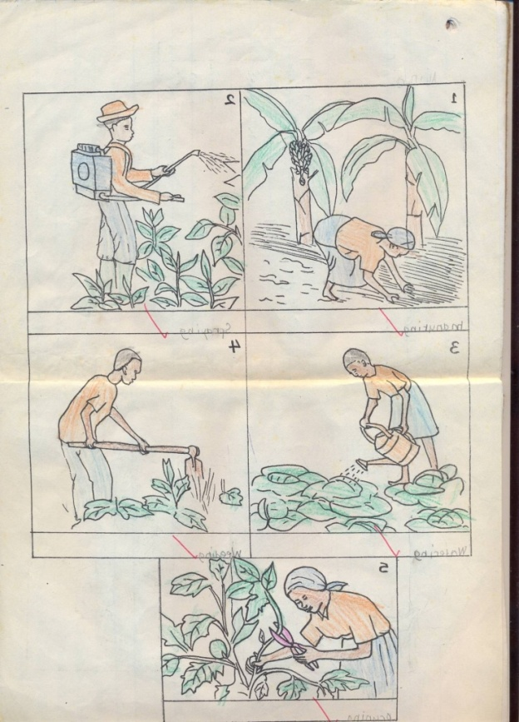**Activity**

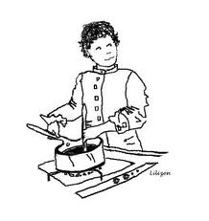

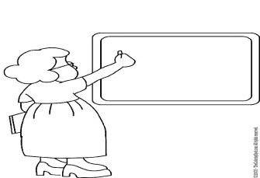

|  |  |  |  |  |
| --- | --- | --- | --- | --- |
| Date | Class | L. Area | Duration | No. of pupils |
|  |  |  |  |  |

**THEME**  : Our school

**SUBTHEME** : activities done at school

**Jumbled story**

**Re – arrange the given sentences and make a good story.**

1. I wash my face.
2. I say my prayers.
3. When I wake up in the morning,
4. I greet my parents.
5. Then I run to school.
6. I put on my uniform.

**A good story**

1. ____________________________________________________
2. ____________________________________________________
3. ____________________________________________________
4. ____________________________________________________
5. ____________________________________________________
6. ____________________________________________________

|  |  |  |  |  |
| --- | --- | --- | --- | --- |
| Date | Class | L. Area | Duration | No. of pupils |
|  |  |  |  |  |

**THEME**  : Our home

**SUBTHEME** : Things in our home

**Vocabulary**

mango, tree, goat, bird, cow egg, hen, duck, banana tree, milk, plate, spoon, basket, cup, fork, television, saucepan, chair, mingling stick, pot, table, cupboard, jerry can, basin, bag, knife, mat, bed, kettle, radio.

**Structure**

What is this / that ?

This is _____________ That is _____________

That is ____________ That is ______________

**Fill in Yes, it is / No, it is not .**

1. Is this a cup?

Yes, it is. Is this a cap?

________________________

2. Is this a chair? Is this a pot?



___________________ ______________________

3. Is this a basket? Is this a bed?

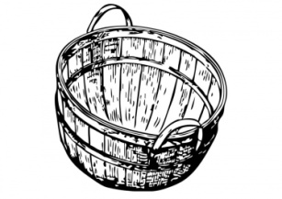

__________________ _____________________

**Listen and write**

__________________ _____________________

__________________ _____________________

__________________ _____________________

4. Use **Yes I do/ No, I do not**

a) Do you eat meat?

b) Do you like snakes?

c)Do you eat stones?

d) Do you like flowers?

|  |  |  |  |  |
| --- | --- | --- | --- | --- |
| Date | Class | L. Area | Duration | No. of pupils |
|  |  |  |  |  |

**THEME** : Our home

**SUBTHEME** : Activities done at home

**COMPETENCES**: Identifies different people in our community and gives their roles.

* Matches people to their roles

**CONTENT** : Roles of people in our community

* Doctor – treats sick people
* Nurse – cares for sick people
* Teacher – teaches pupils
* Shopkeeper – sells in shop
* Carpenter – makes furniture
* Cobbler – mends shoes

**Exercise**

1. Match people to their work.

Doctor mends shoes

Teacher treats sick people

Shopkeeper teaches pupils

Cobbler sells in shop

1. Write one word for the underlined group of words

My mother is **a person who cares for the sick people**

That is **a man who makes chair, beds and doors**

My aunt is a **person who teaches pupils**

My sister is **a person who sells things in the shop**

|  |  |  |  |  |
| --- | --- | --- | --- | --- |
| Date | Class | L. Area | Duration | No. of pupils |
|  |  |  |  |  |

**THEME** : Our community

**SUBTHEME** : People in our community

**Vocabulary**

Doctor, shopkeeper, priest, farmer, nurse, policeman, pastor, builder, teacher, cook, carpenter, driver, mechanic, man, girl, boy, woman, shopkeeper, teacher .

**Write small words from big words.**

Shopkeeper – shop

Carpenter – car

Teacher – tea

Policeman - police

**Structures.**

Who is this / that? 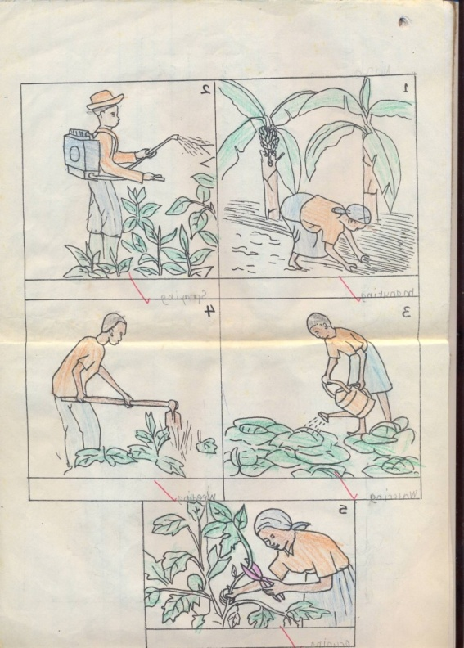

This is a farmer.



This is a _________________________

 This is a __________________________

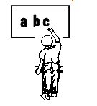What is she / he doing?

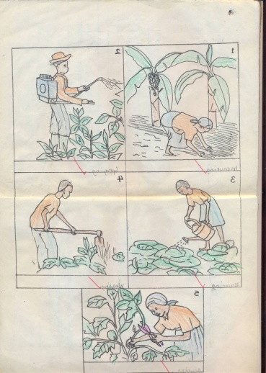

What are they doing?

|  |  |  |  |  |
| --- | --- | --- | --- | --- |
| Date | Class | L. Area | Duration | No. of pupils |
|  |  |  |  |  |

**THEME** : Our home

**SUBTHEME** : Activities in our community

**COMPETENCES**: Reads the new words correctly

* Uses the given words to complete the structures correctly

**CONTENT** : Activities done in our community

**Vocabulary**

fish plant harvest sell dry weed dig treat

slash model pound grind

**Structures**

What are you doing?

e.g. I am fishing

What is he/ she doing?

He is digging

She is treating

**Exercise**

1. Listen and write
2. Fill in the missing letters

f __sh w __ __d sl __sh pl __nt

h __rvest gr __nd

1. 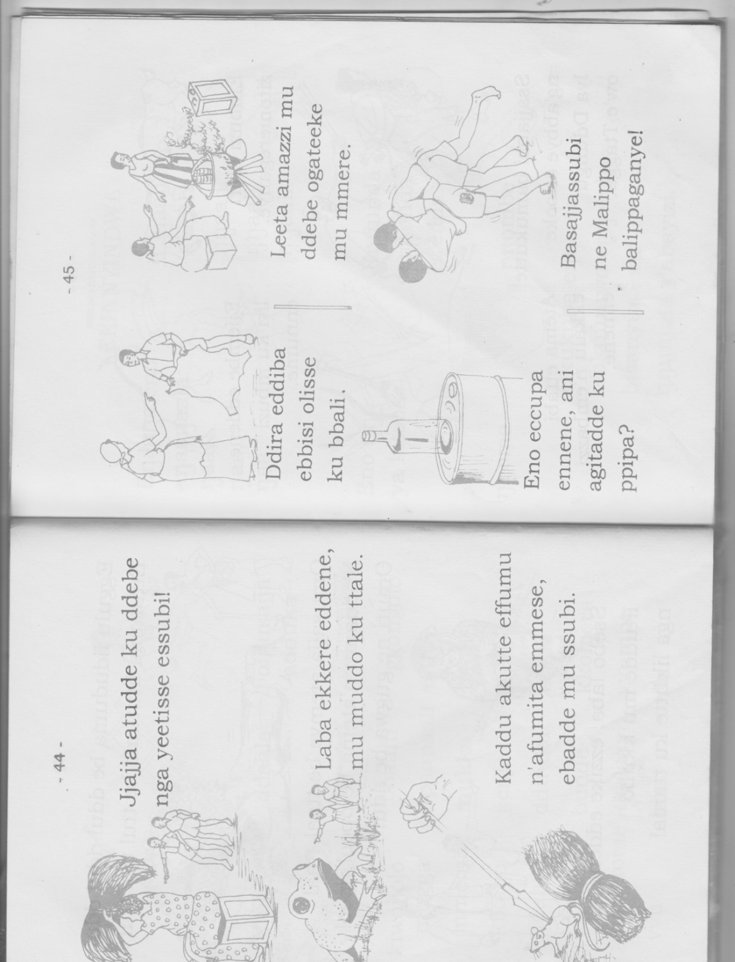Who is she/ he?



_______________ __________________





________________ ___________________

4.Who are they?

|  |  |  |  |  |
| --- | --- | --- | --- | --- |
| Date | Class | L. Area | Duration | No. of pupils |
|  |  |  |  |  |

**THEME** : Our community

**SUBTHEME** : Important places in the community

**CONTENT** : Vocabulary

**Vocabulary**

post office, hospital, church, mosque, school, bank, police station, market, shop, home, clinic, well.

**Structures**

What is this / that?

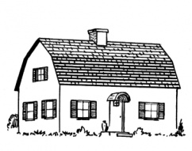show me a _________(orally)

This is a home.

**Exercise**

**Structures**

What is this / that?



This is ___________

This is __________

This is ___________

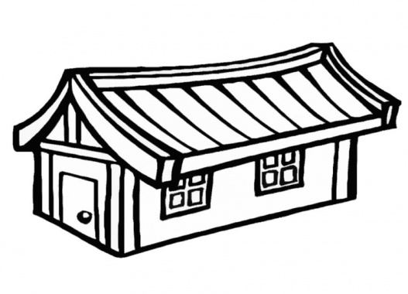

That is ____________

**Circle the old man out**

1. Book pencil **food**  ruler
2. Boy girl brother **cow**
3. Teacher bursar, **uncle** matron

**Exercise**

Listen and write

_____________ __________

_____________ ____________

**Circle the old man out**

1. Paper knife axe panga
2. Orange apple stone mango
3. Hen cow goat dog
4. Brother teacher sister mother

|  |  |  |  |  |
| --- | --- | --- | --- | --- |
| Date | Class | L. Area | Duration | No. of pupils |
|  |  |  |  |  |

**THEME** : Our community

**SUBTHEME** : People in our community

**CONTENT** : Jumbled sentences

1. The doctor treated her.
2. She fell sick.
3. Teacher took her back home.
4. Mother took her to the hospital.
5. One day, Jane went to school.

**Re-arrange sentences to make a good story.**

1. While at school she fell sick.
2. One day, Jane went to school.
3. Her teacher took her to the school nurse.
4. After classes her friend Jolly took her home.
5. The school nurse treated jane

**Exercise**

1. They started playing with the ball.
2. A speeding car knocked them down.
3. She met her friend Sarah
4. One day, Helen was going to school
5. Sarah had a ball.

**Re-arrange sentences to make a good story.**

1. ______________________________________________________
2. ______________________________________________________
3. ______________________________________________________
4. ______________________________________________________
5. ______________________________________________________

|  |  |  |  |  |
| --- | --- | --- | --- | --- |
| Date | Class | L. Area | Duration | No. of pupils |
|  |  |  |  |  |

**THEME** : Our community

**SUBTHEME** : Activities done in our community.

**CONTENT** : Free composition writing.

**Guidelines**

1. What is your name?
2. Where do you live?
3. Which people are found in your community?
4. Who treats sick people?
5. What does a farmer do?

|  |  |  |  |  |
| --- | --- | --- | --- | --- |
| Date | Class | L. Area | Duration | No. of pupils |
|  |  |  |  |  |

**THEME** : Human body and Health

**SUBTHEME** : External parts of the body

**Vocabulary**

head eye nose mouth face

chest leg knee ear stomach

foot thigh neck fingers toe

thumb hand arm shoulder

**Structures**

Show me your _________________________________

This is my_____________________________________

What is this? (do exercise on pg. 62)

 Mk.Bk. 1

How many ………….. are there?

What is this?

What are these? (Pg 39)

*Write the words correctly*

*gel _________ seno ______________*

*toof __________ era_____________ ckne______________*

listen and write

|  |  |  |  |  |
| --- | --- | --- | --- | --- |
| Date | Class | L. Area | Duration | No. of pupils |
|  |  |  |  |  |

**THEME** : Human body and Health

**SUBTHEME** : External parts of the body.

**Vocabulary**

Eyes ears legs hands

Fingers feet knees

**Structures**

What are these / those?

These are my ______________________________________

**Read and answer the following questions.**

1. How many legs do you have?

I have ________________________legs.

2. How many legs do you have?

3. How many hands do you have?

4. How many eyes do you have?

5. How many ears do you have?

I use ____________________________ to see.

I use ____________________________to hear

|  |  |  |  |  |
| --- | --- | --- | --- | --- |
| Date | Class | L. Area | Duration | No. of pupils |
|  |  |  |  |  |

**THEME** : Human body and healthy

**SUBTHEME** : Common disease

**COMPETENCES**: Names of diseases and some common vectors

**CONTENT**: **vocabulary**

Headache, malaria, cough, mosquito houseflies, pin, polio, measles

**Structure**

Are you well?

Yes, I am

Are you ill?

No, I am not.

**Activity**

1. Write these words correctly

achhead _________ oughc _______ mslesea __________

quitomos _______ nip _________ oiplo ____________

1. Draw people suffering from these diseases

Polio __________ measles ___________

1. Fill in the missing letters

M__asles P___lio c __ugh

M _squito

Listen and write

__________________ ______________

_________________ ______________

|  |  |  |  |  |
| --- | --- | --- | --- | --- |
| Date | Class | L. Area | Duration | No. of pupils |
|  |  |  |  |  |

**THEME** : Human body and Health

**SUBTHEME** : Personal hygiene

**COMPETENCES**: Reading the words correctly

Spelling, pronouncing and writing the exercise properly.

**CONTENT**: **Things we use to clean our body**

soap, water, basin, towel, comb, brush

**Structure**

What are you doing? I am ………….

What is she/ he doing? She / he is ………….

**Exercise**

1. Name these pictures



______________

_______________

_______________ **Geisha ___________**

1. Draw these things we use to clean our bodies

|  |  |  |  |
| --- | --- | --- | --- |
|  |  |  |  |
| toothpaste | comb | basin | stone |

1. What is she/ he doing?

|  |  |  |  |  |
| --- | --- | --- | --- | --- |
| Date | Class | L. Area | Duration | No. of pupils |
|  |  |  |  |  |

**THEME** : Human body and Health

**SUBTHEME** : Personal hygiene

Guided picture composition

**The five senses**

My name is _____________________________________

******I have five senses**

_____________for seeing



nose for _____________________

______________for tasting.

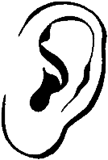

_______________________for hearing.

Skin for __________________________.

*Join these words and form new words*

*Cup + board = cup board*

*Head + teacher = head teacher*

***Exercise***

*Head + boy = ________*

*Chalk + board = ________*

*Foot + ball = ____________*

**P.1 COMPREHENSION LESSON NOTES FOR TERM I 2019**

|  |  |  |  |  |
| --- | --- | --- | --- | --- |
| Date | Class | Subject | Duration | No. of pupils |
|  |  |  |  |  |

**THEME :** Our school

**SUBTHEME :** People found at school

**CONTENT :** story

**Read the story and answer the given questions**

**My school**

My name is ________. I am six years old. I go to Cornerstone Junior School. At our school we have teachers, drivers, cooks, cleaners, gatekeepers, and matrons. Our director is Mrs. Muyonga Faith and the head mistress is Miss. Immaculate Mawanda. My class teacher is ___________. I like my school.

**Questions.**

1. Write the title of the story x 2
2. Where do you go to school?
3. Name four people found in your school
4. Draw your school
5. What is the name of your school?

|  |  |  |  |  |
| --- | --- | --- | --- | --- |
| Date | Class | L. Area | Duration | No. of pupils |
|  |  |  |  |  |

**THEME : Our school**

**SUBTHEME : Things found at school**

**CONTENT : guided composition .**



When our _________enters the class. She rubs the _______ with

a __________ then gets the pieces of __________and writes on the chalk board. She also gets a ___________ and uses it when teaching

pointer, chalk, chalkboard, teacher, duster

|  |  |  |  |  |
| --- | --- | --- | --- | --- |
| Date | Class | L. Area | Duration | No. of pupils |
|  |  |  |  |  |

**THEME : Our Home**

**SUBTHEME : People at home**

**CONTENT : story**

**Reading the story and answer questions correctly**

**Buule’s family**

Buule is a boy. He is six years old. He lives with his father and mother. He is the first born in their family. He has two sisters, Sarah and Ruth. Buule also has three brothers James, Tom and Ivan. They all go to Cornerstone Junior School. Buule likes playing with his sisters and brothers.

**Questions`**

1. Write the title of the story?
2. How old is Buule?
3. How many brothers does Buule have?
4. Buule has two sisters ______ and _____
5. Write the names of Buule’s brothers

|  |  |  |  |  |
| --- | --- | --- | --- | --- |
| Date | Class | L. Area | Duration | No. of pupils |
|  |  |  |  |  |

**THEME : Our Home**

**SUBTHEME : Things in a home**

**CONTENT : Dialogue about family**

**The family**

Read the dialogue below and answer questions about it.

**Ritah** : Hullo Bob!

**Bob** : Hullo! How are you?

**Ritah** : I am fine. How are your brothers and sisters?

**Bob** : They are fine except my younger brother who is sick.

**Ritah** : Oh! Sorry, has your mother given him medicine?

**Bob** : No, but my father has taken him to the hospital.

**Ritah** : I wish him a quick recovery. Good bye

**Bob** : Good bye.

**Questions**

1. What is the dialogue about?

The dialogue is about_____________________

*2. How many people are in the dialogue?*

3. *Who spoke first?*

4.Name the people taking in the dialogue

5. Whose younger brother is sick?

6. Give the names of Buule’s brothers

7. Write the title of the dialogue

*8. Who are the people talking in the dialogue?*

*9. Who spoke last?*

|  |  |  |  |  |
| --- | --- | --- | --- | --- |
| Date | Class | L. Area | Duration | No. of pupils |
|  |  |  |  |  |

**THEME : Our Community**

**SUBTHEME : People in our community**

**CONTENT : A poem about community**

**Community community community**

A group of people living and working together

In the community, we find people like;

Teachers, doctors, drivers, nurses, lawyers and police men.

They all live happily in the community

By Kirabo Ronia

**Questions**

1. What is the poem about?
2. ______________ is a group of people living and working together.
3. Name three people found in our community.
4. Draw these people found in our community.

teacher

doctor

driver

policeman

1. Write the title of the poem
2. *Who wrote the poem?*
3. *How many lines has the poem?*

|  |  |  |  |  |
| --- | --- | --- | --- | --- |
| Date | Class | L. Area | Duration | No. of pupils |
|  |  |  |  |  |

**THEME : Our Community**

**SUBTHEME : Important places in our community**

**CONTENT : A Story .**

**Important Places**

My name is Paul. My father is a doctor. He works at the hospital. My mother is a police woman. She works at the police station. On Sunday, we go to church. The reverend leads prayers in the church. When I go to school, my teachers teach me well. I like my school, Cornerstone Junior School

**Questions**

1. What is the name of the boy in the story?
2. Where does Paul’s father work?
3. Where do you go for prayers on Saturday?
4. Draw a church
5. What is the title of the story?
6. Write the title of the story

|  |  |  |  |  |
| --- | --- | --- | --- | --- |
| Date | Class | L. Area | Duration | No. of pupils |
|  |  |  |  |  |

**THEME : Our Community**

**SUBTHEME : Important places in our community**

**CONTENT : A poem**

**Work Places**

Do you want to see a teacher?

Go to school.

Do you want to see a priest?

Go straight to church.

If you want to see a judge,

Go to a nearby court.

If you want to see a policeman,

Go to the police station.

By Joan

Questions

1. What is the poem about?
2. How many lines has the poem?
3. Where can you find a priest?
4. Who wrote the poem?
5. Draw a police man
6. *What is the title of the poem?*
7. *Write the title of the poem*
8. *Where does a policeman work?*

|  |  |  |  |  |
| --- | --- | --- | --- | --- |
| Date | Class | L. Area | Duration | No. of pupils |
|  |  |  |  |  |

**THEME : Human body and health**

**SUBTHEME : Common diseases and their causes**

**CONTENT : guided picture composition**

**A RHYME**

**COW! COW! COW!**

You are my friend.

Your young one is a calf.

You give me milk,

You give me meat

Oh thank you cow

By Rehema

**Questions**

1. Name the animal mentioned in the rhyme above
2. Write any two things got from a cow.
3. Who wrote the rhyme above?
4. How many lines has the rhyme?
5. Draw a cow
6. What is the rhyme about?
7. *Write the title of the rhyme*

|  |  |  |  |  |
| --- | --- | --- | --- | --- |
| Date | Class | L. Area | Duration | No. of pupils |
|  |  |  |  |  |

**THEME : Human body and health**

**SUBTHEME : Common diseases and their causes**

**CONTENT : Letter writing**

**Love letter**

Cornerstone Junior School

P.o Box 704, Mukono

22nd January, 2015

Dear Mummy,

How are you my mother? How are my sisters and brothers?

I hope everyone is fine at home.

Mummy, I have written to thank you for paying my school fees.

I love you so much. May God bless you.

Your son / daughter

Brenda / Peter